Punnett Square Practice Worksheet

Part A: Vocabulary - Match the definitions on the left with the terms on the right.
____ 1. genotypes made of the same alleles |  |  |  |  |  |  |  |  | A. alleles
____ 2. different forms of genes for a single trait |  |  |  |  |  |  |  |  | B. dominant
____ 3. gene that is always expressed |  |  |  |  |  |  |  |  | C. heterozygous
____ 4. gene that is expressed only in the homozygous state |  |  |  |  |  |  |  |  | D. homozygous
____ 5. genotypes made of two different alleles |  |  |  |  |  |  |  |  | E. recessive
Circle the choices that are examples of each of those words.
6. Homozygous dominant |  |  | AA |  | Gg | KK | mm | uu | Rr | TT
7. Homozygous recessive |  |  | ee |  | Ff | HH | Oo | qq | Uu | ww
8. Genotypes in which dominant gene must show
AA | Dd | EE | ff |  | Jj | RR | Ss
9. Genotypes in which recessive gene must show
aa | Gg | Ff | KK |  | rr | Oo | Tt

Part B: Punnett Squares

10. Examine the following Punnett squares and circle those that are correct.
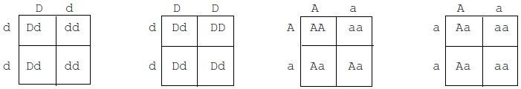

- What do the letters on the outside of the Punnett square stand for?

- What do the letters on the inside of the Punnett square stand for?

- In corn plants, normal height, N, is dominant to short height, n. Complete these four Punnett squares showing different crosses. Then, circle all of the homozygous dominant offspring. Put an X through all the heterozygous offspring. Leave all the homozygous recessive offspring unshaded.
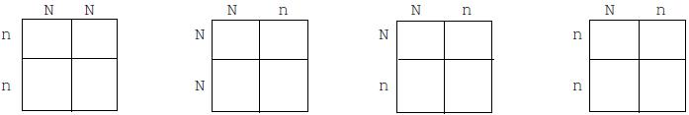
- In guinea pigs, short hair, S, is dominant to long hair, s. Complete the following Punnett squares according to the directions given. Then, fill in the blanks beside each Punnett square with the correct numbers.

a. One guinea pig is Ss and one is ss.
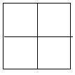
Expected number of offspring:
____ Short hair (SS or Ss)
____ Long hair (ss)

b. Both guinea pigs are heterozygous for short hair.
Expected number of offspring:
____ Short hair
____ Long hair

Part C: Monohybrid Cross Problems – Make a punnett square to show your work.

- Hornless (H) in cattle is dominant over horned (h). A homozygous hornless bull is mated with a homozygous horned cow. What will be the genotype and phenotype of the offspring?

Genotype

Phenotype

- In tomatoes, red fruit (R) is dominant over yellow fruit (r). A plant that is homozygous for red fruit is crossed with a plant that has yellow fruit. What will be the genotype and phenotype of the offspring?

Genotype

Phenotype

- In humans, being a tongue roller (R) is dominant over non-roller (r). A man who is a non-roller marries a woman who is heterozygous for tongue rolling.

Father’s phenotype ________ Mother’s phenotype _________

Father’s genotype ________ Mother’s genotype _________

What is the probability of this couple having a child who is a tongue roller? ________

- Brown eyes in humans are dominant to blue eyes. A brown-eyed man, whose mother was blue-eyed, marries a brown-eyed woman whose father had blue eyes.

What is the probability that this couple will have a blue-eyed child? _______

Answer the following questions by completing the punnett square.

- In pea plants, round (R) is dominant to wrinkled (r). A heterozygous female is crossed with a wrinkled male. Make a Punnett Square to determine the possible offspring.

    - What are the possible genotypes of the offspring?

    - What are the possible phenotypes of the offspring?

    - What is the probability of having an offspring that is round?

    - What is the probability of having an offspring that is homozygous?

- The color of flowers in snap dragons shows incomplete dominance. Red (CRCR) and white (CWCW) are homozygous and pink (CRCW) is heterozygous.

  - If a red snap dragon is crossed with a white snap dragon, what is the phenotype of the offspring?

  - What are the possible genotypes of the offspring?

  - A pink flower is crossed with a red flower. Make a Punnett Square to determine the possible offspring.
  - What is the probability of the offspring being red?

  - What is the probability of the offspring being white?

  - What is the probability of the offspring being pink?

- Sickle Cell Anemia is condition that shows codominance. The genotype for normal blood cells is NN. Sickle cell trait is the heterozygous condition (NS) and contains both normal and sickle shaped blood cells. Sickle cell disease (SS) is when all of the blood cells are sickle-shaped and has lifelong medical implications. A man with sickle cell trait has a child with a woman with sickle cell trait.

    - Complete the Punnett Square.

    - What is the probability of having a child with sickle cell trait?

    - What is the probability of having a normal offspring?

    - What is the probability of having a child with sickle cell disease?

22. A man with Type O blood marries a woman with heterozygous Type A blood.

  - What are the possible genotypes of the offspring?

  - What are the possible phenotypes of the offspring?

  - What is the probability of each genotype?

  - What is the probability of each phenotype?

- In humans colorblindness (b) is an example of a sex-linked recessive trait. In this problem, a male with colorblindness marries a female who is not colorblind but carries the (b) allele. Using a Punnett square, determine the genotypic and phenotypic probabilities for their potential offspring.

Genotype of offspring:

Phenotype of offspring:

- A man that has an AB blood type has a child with a woman with type B blood. Can they have a type O child? Use a punnett square or punnett squares to show your work.

